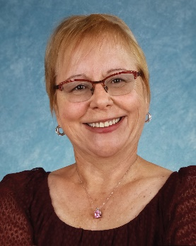**Leona Meditz**

*Experienced Entrepreneur founder and director of* [*HCP Wellnet*](https://gowellnet.com/2593-2/)

*Impassioned Expert foremost authority integrating oral wellness into medical/dental practice.*

*Seasoned Speaker-Keynote, Study clubs, TV, Radio, Retreats*

*Product Producer—Developed Doctor recommended Organic Oral Care Hygiene Products*

*Thought Leader—2002 Introduced CO2 Laser to US; Co Designed LAPT Protocols; Published Monthly in Dentistry Today Magazine’s Todays Dental News*

[leona@gowellnet.com](mailto:leona@gowellnet.com) 480-225-0700

Topics for Keynote  Seminars Workshops:

Learn Step-by-Step HOW to design a profitable wellness center from diagnostics thru case acceptance that has worked for hundreds of dentists nationwide. **Includes FREE Practice Oral Health X-Ray**

**“This works! I turned my loss leader hygiene department into a profit generating wellness center” Walter Below, DMD Ohio**

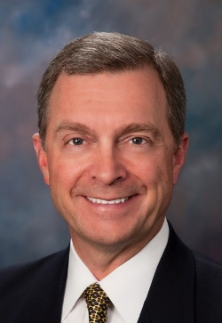

Topic: Turn Your Hygiene Department into a Wellness Center

***“I learned how this simple implant pre-surgical prep may prevent Peri-implantitis!”* Suhail Mati, DDS Michigan**

A Landmark Research program is now underway to see if using a six week pre-surgical protocol can prevent peri-implantitis. Be the first to learn what it is. **Attendees receive the written protocol.**

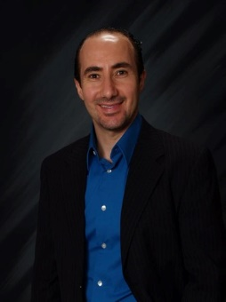

Topic: Preventing the Dental Implant Time Bomb 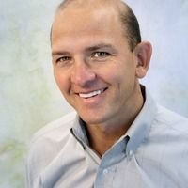 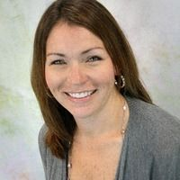Topic: Sustaining Periodontal Health with Nutritional Supplements

**Patient health is sustained with these nutritional supplements.**

**Drs. Scott Parr and Tara Frey DDS Virginia**

No matter what periodontal therapies you use, research supports adding nutritional supplements sustains oral health with healthy side effects. This scientific approach helps you weigh the advantages of nutritional supplements. **Attendees receive research reference links and nutritional matrix.**